**CSC380 Software Construction & Development**

**Project Report**

**FYP Management System**



**Submitted by:**

Muhammad Faseeh Ur Rehman 2023-SE-01

Ahmad Ali 2023-SE-14

Muhammad Rizwan 2023-SE-32

**Submitted to:**

Mr. Ali Raza

Dated: 4th Jan 2026

Department of Computer Science

**University of Engineering and Technology Lahore, New Campus**

# Design Document:

## Class Diagram:

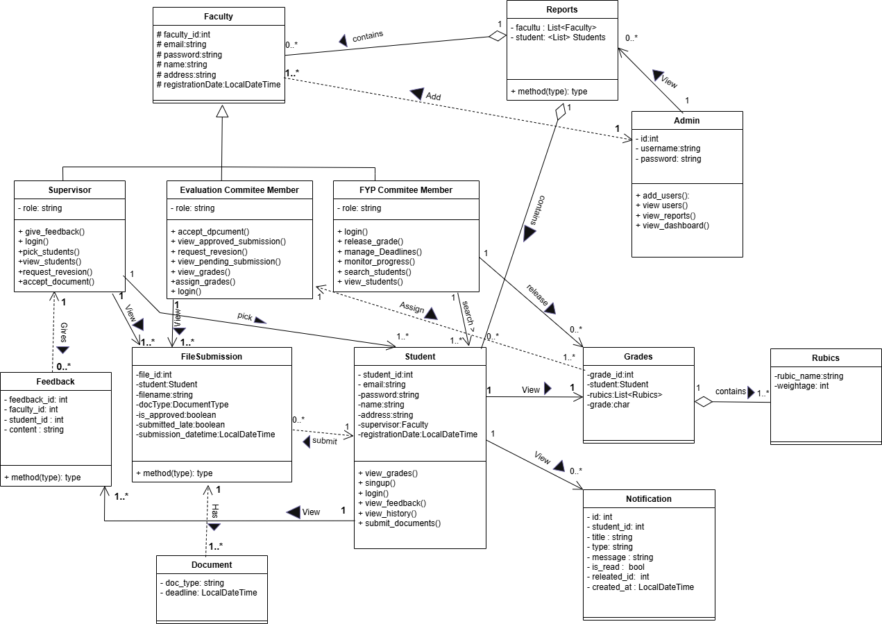

## Usecase Diagram:

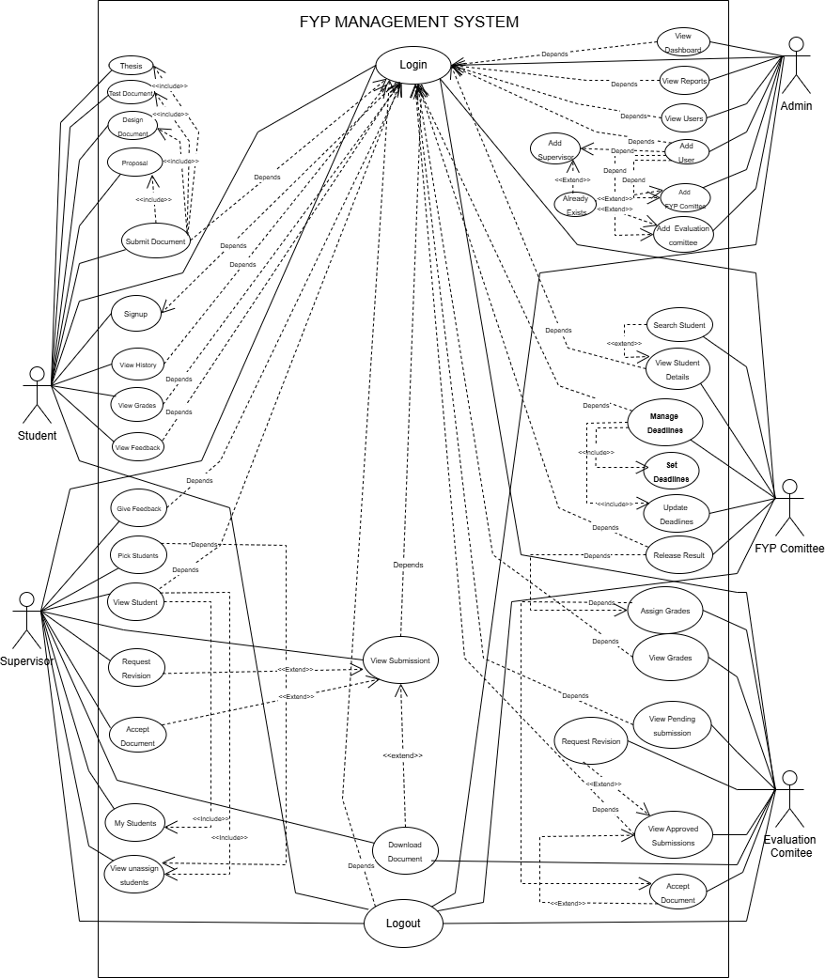

## ER Diagram:

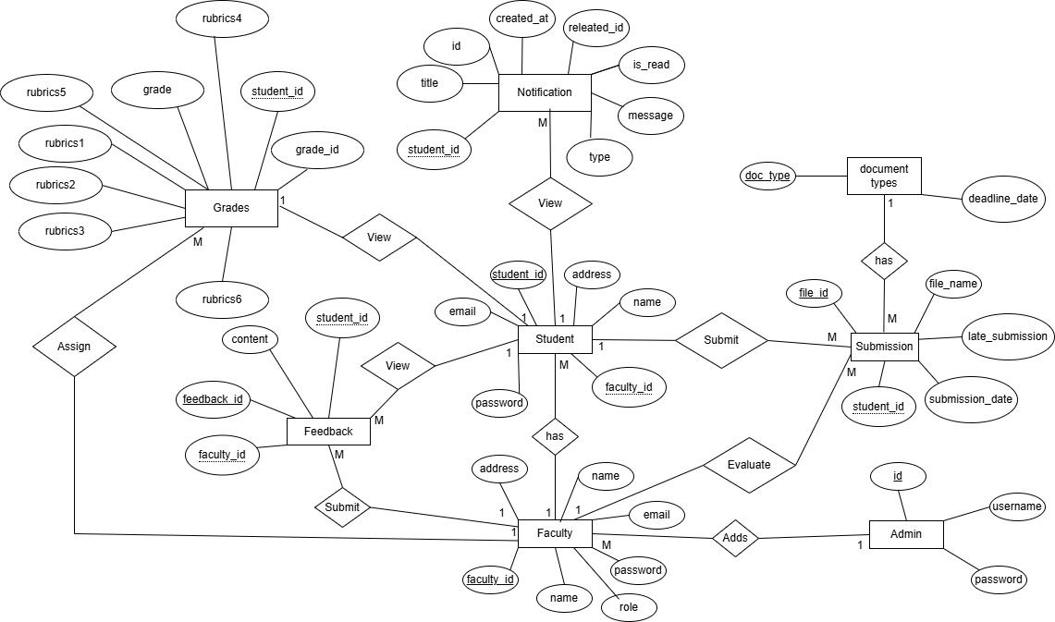

## Sequence Diagrams:

### Signup:

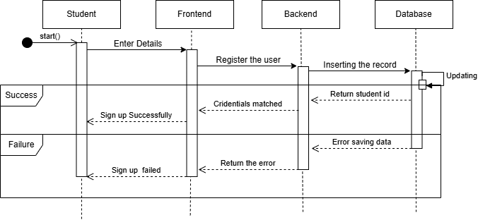

### Login:

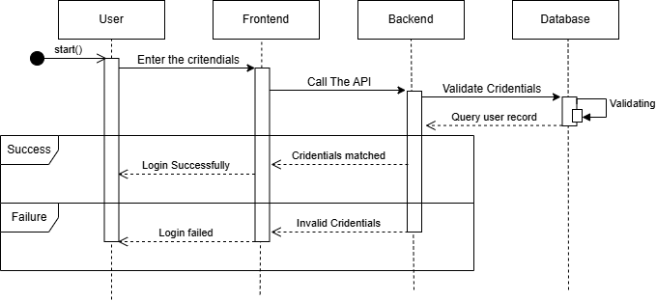

### Upload Proposal:

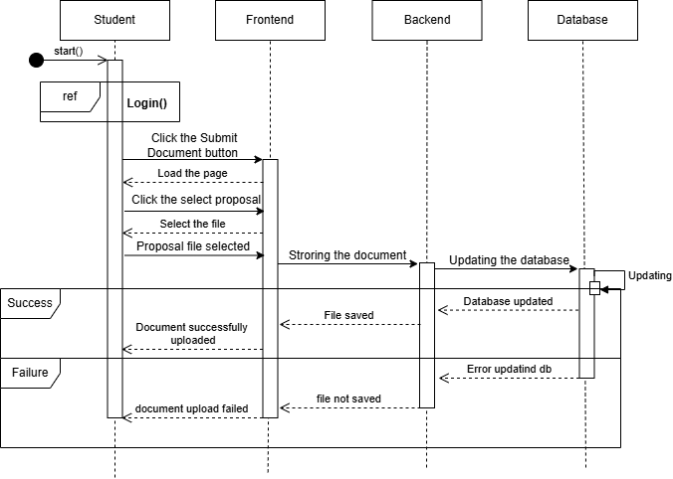

### Upload Design Document:

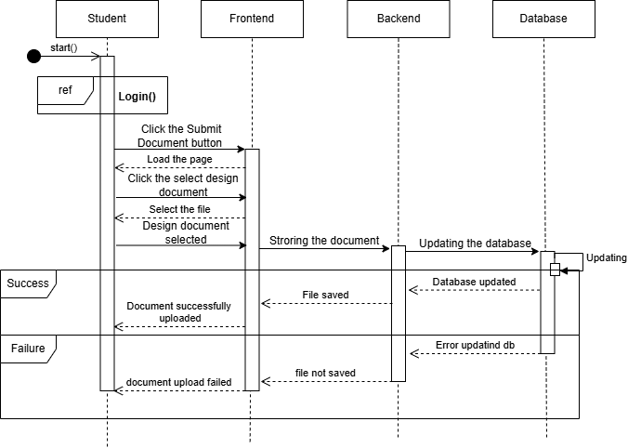

### Upload Test Document:

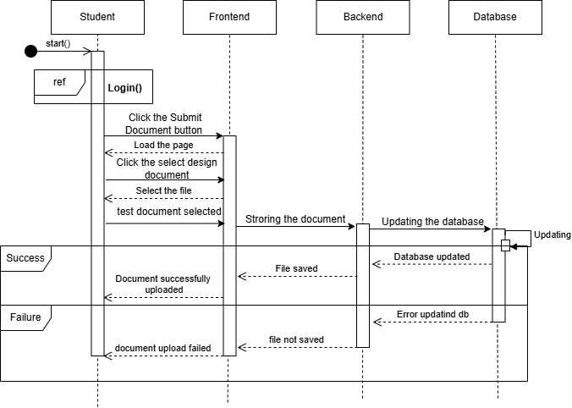

### Upload Thesis:

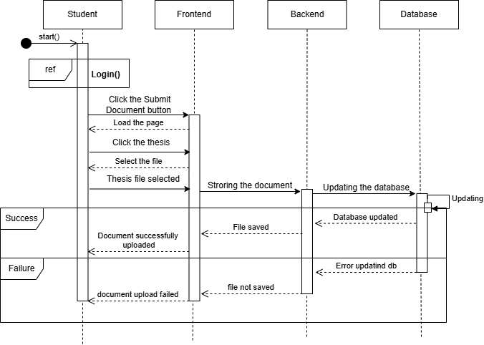

### View Grades:

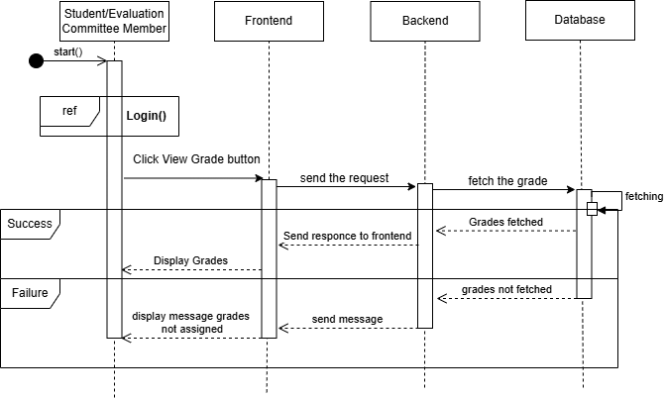

### View Feedback:

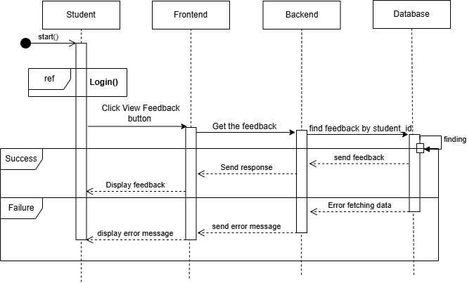

### View History:

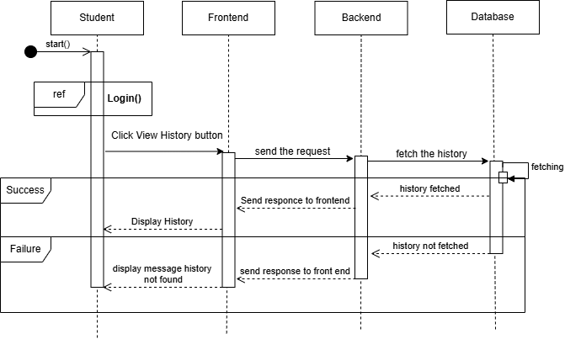

### Give Feedback:

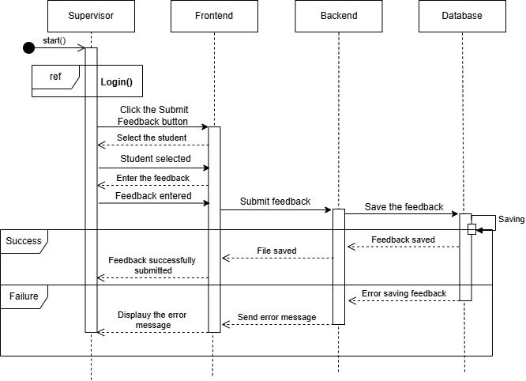

### My Students:

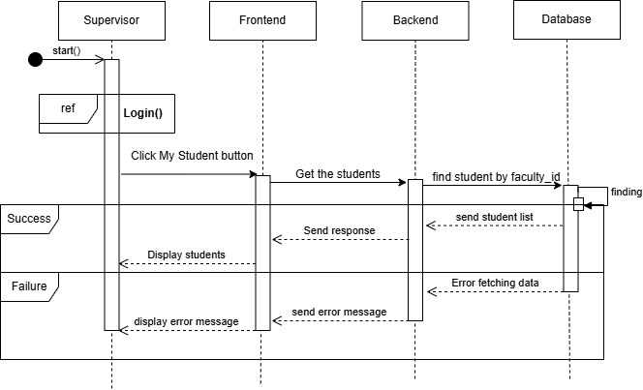

### Pick Student:

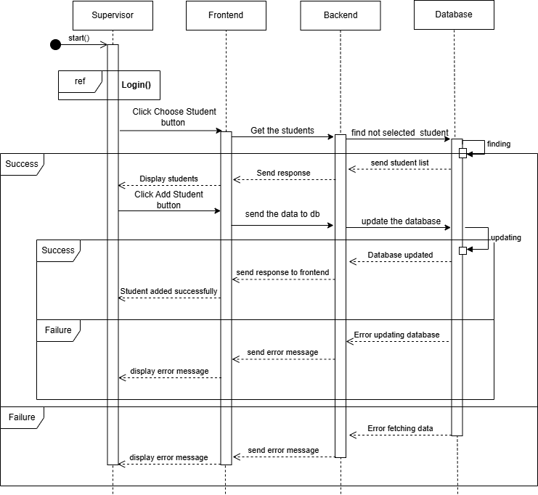

### View Submissions:

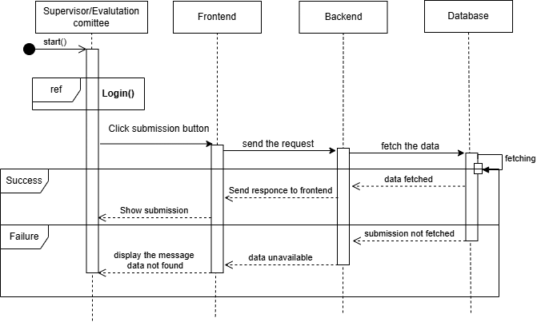

### Download Document:

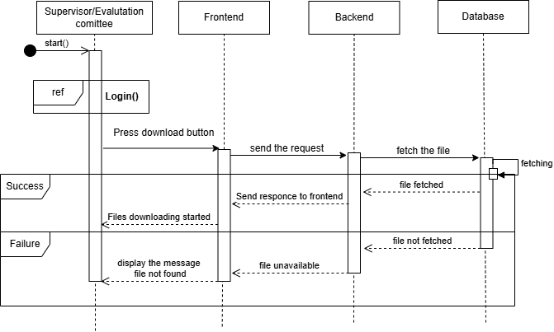

### Request Revision:

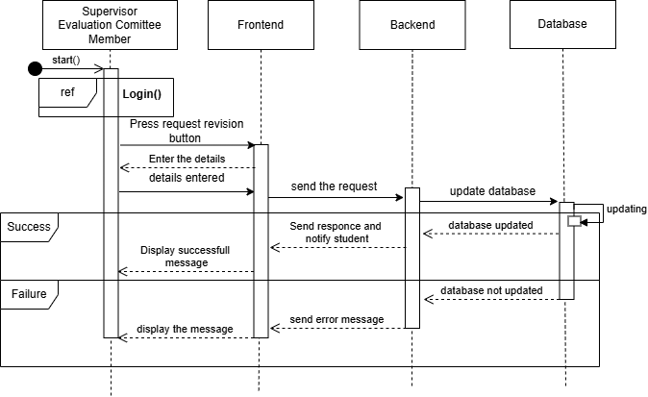

### Accept Document:

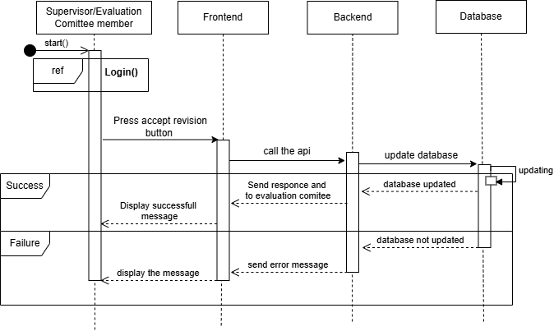

### Assign Grades:

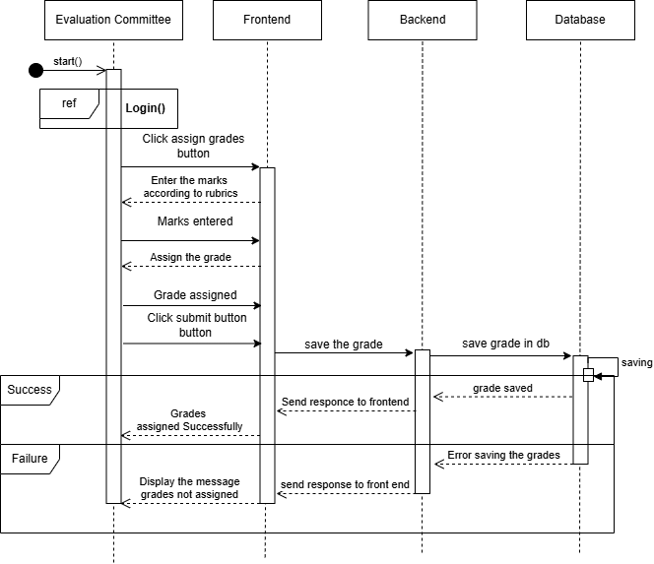

### View Pending Submissions:

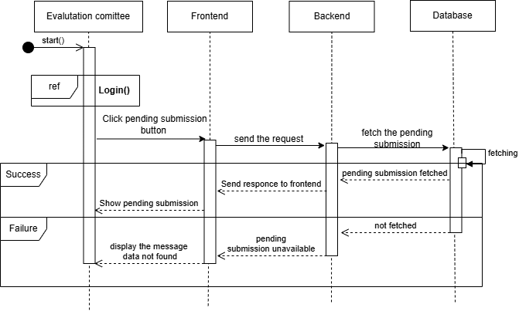

### Set Deadlines:

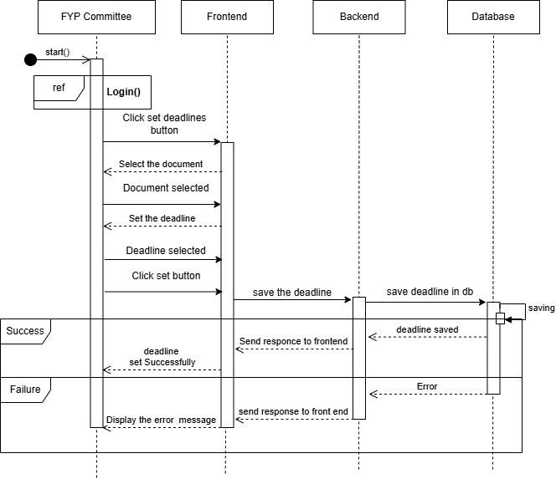

### Update Deadlines:

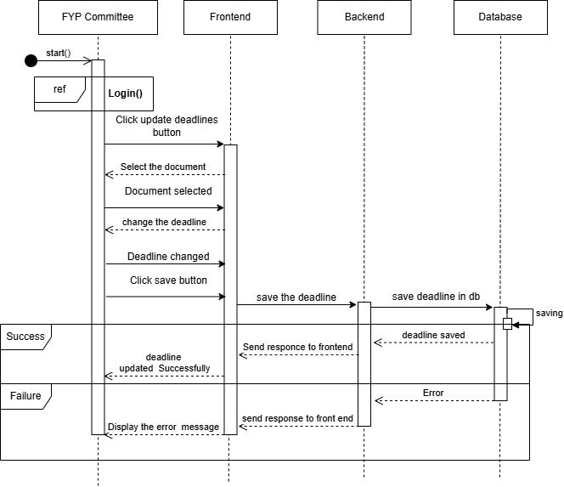

### View Student Details:

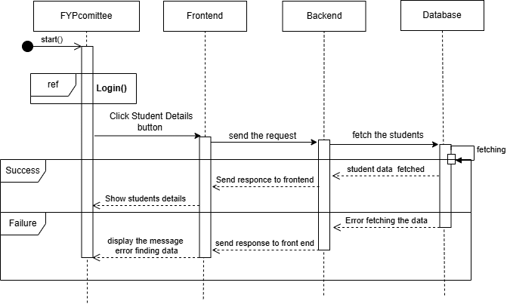

### Search Student:

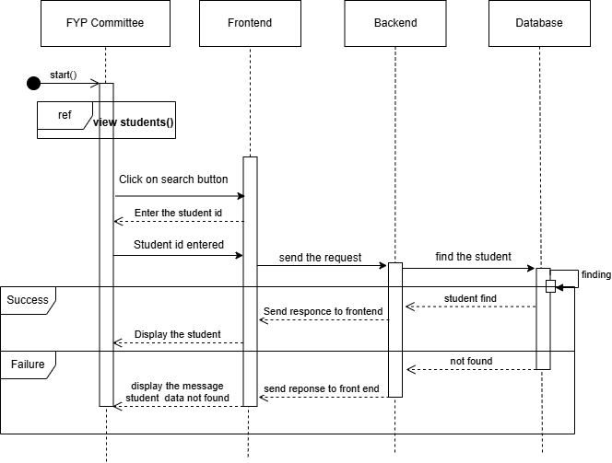

### Release Result:

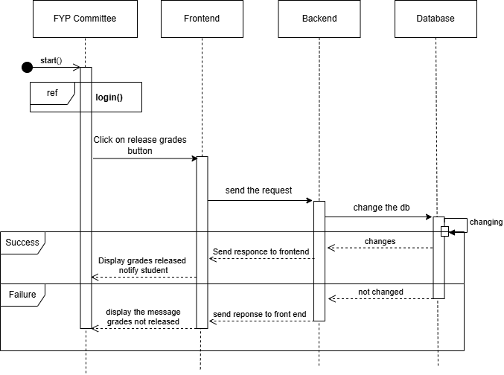

### View Dashboard:

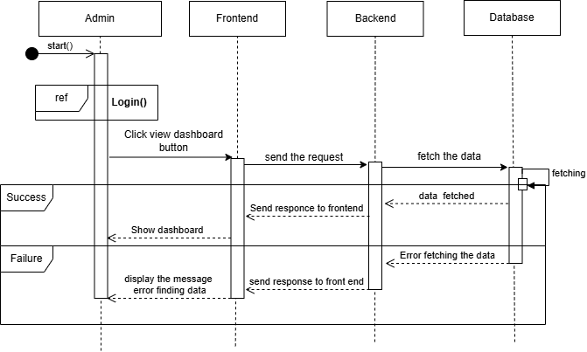

### View Reports:

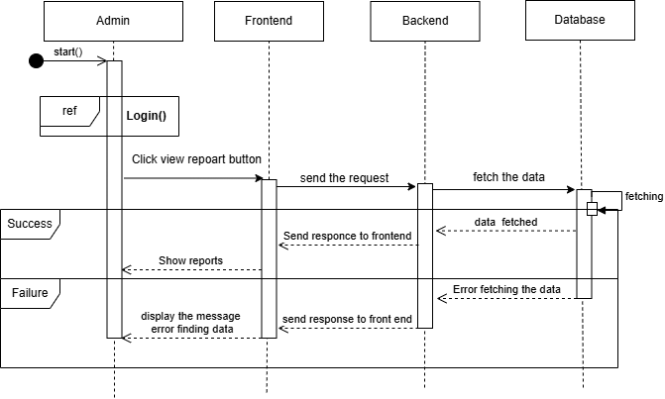

### View Users:

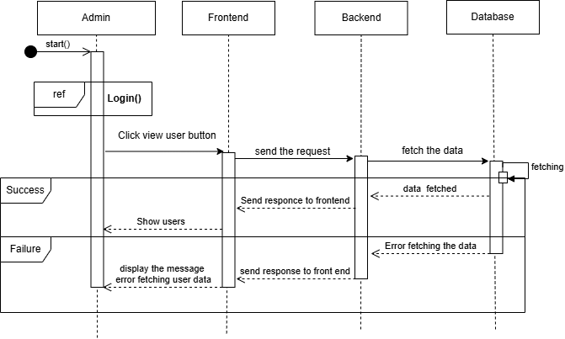

### Add Users:

## Architecture Diagrams:

